**INVENTORY ADJUSTER**

**TO START  
1.) Menu**

**2.) Transaction  
3.) Inventory adjust**

Inventory Adjuster

Transaction

Menu

1 1*1*

2 1*1*

3 1*1*

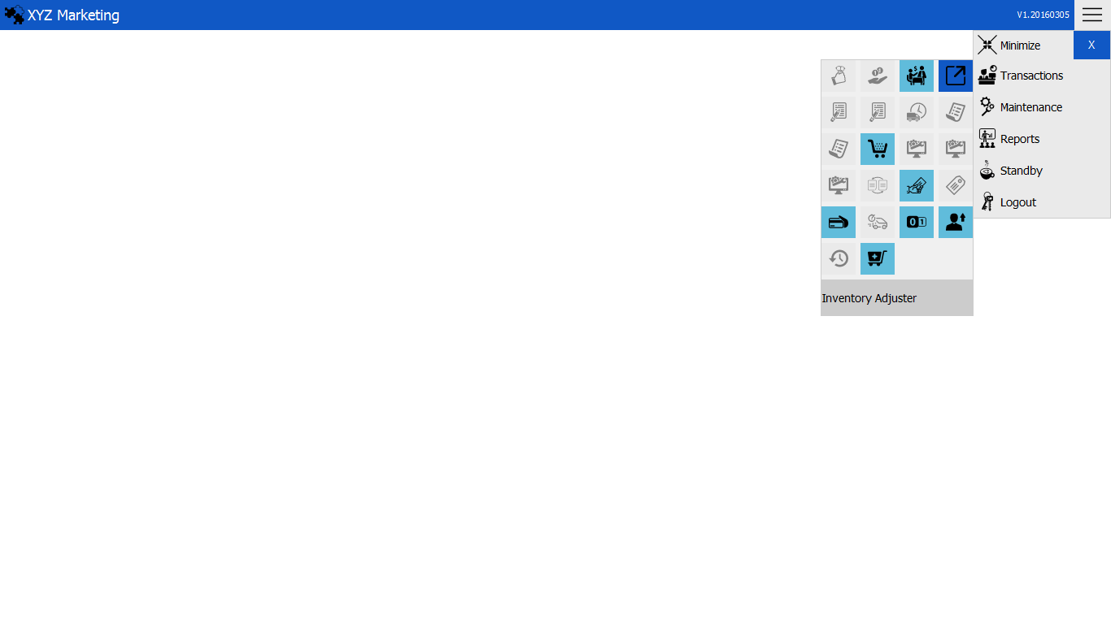

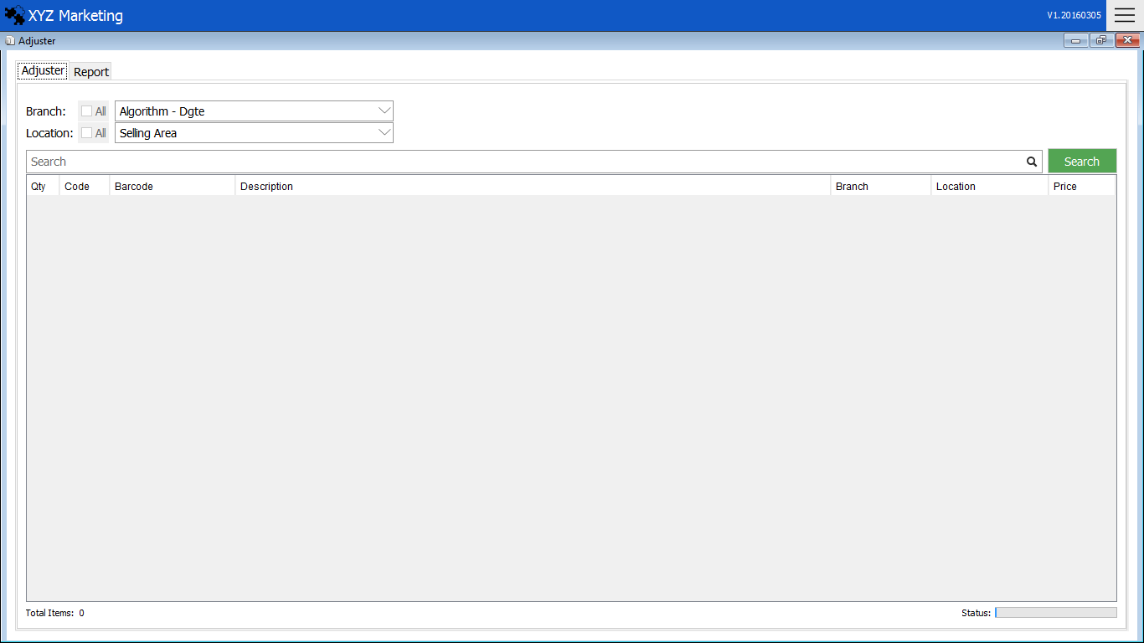 **TO ADJUST INVENTORY  
 1.) Select branch & location   
 2. ) Search item  
 3. ) Search**

We can edit item description

** 1.) Select branch & location**

Choose the branch and location of stock wanted to adjust.

1. **Search item**



You can search item by using   
a. ) Item code  
b. ) Barcode  
c. ) Description

s

1. **Search**

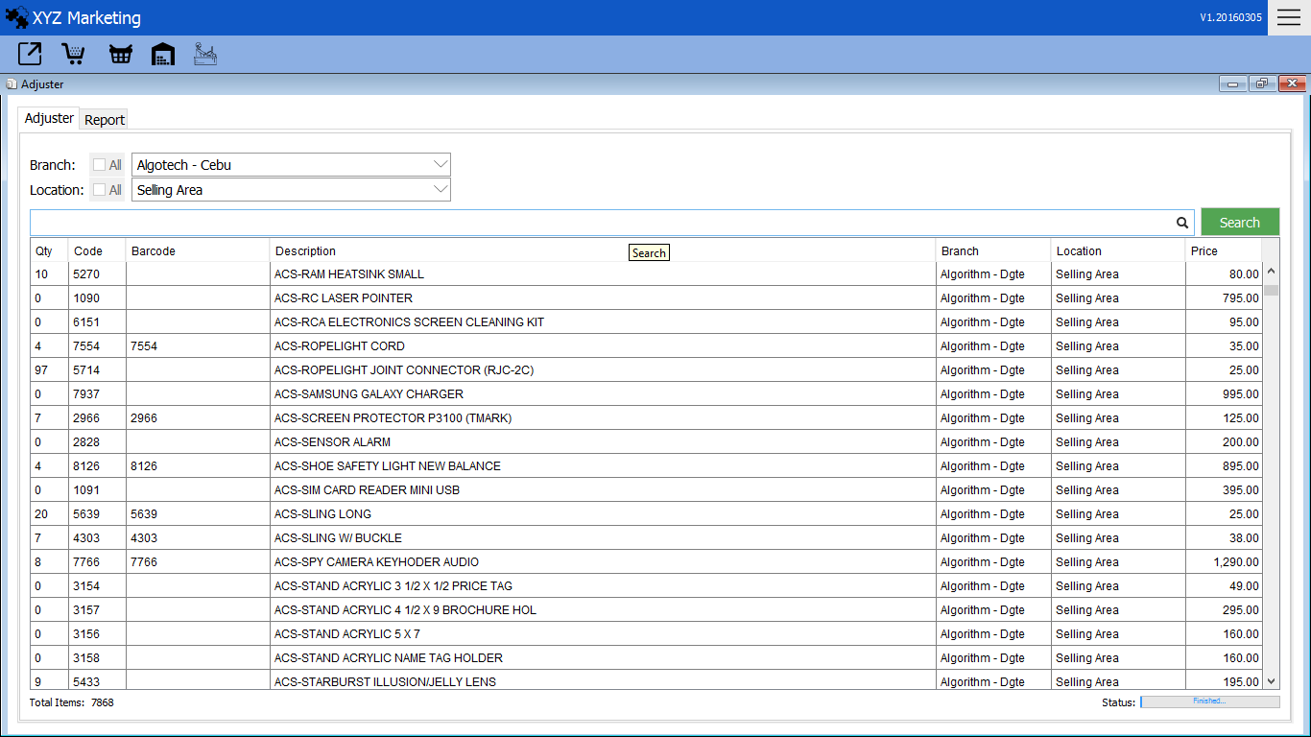

You can adjust the item by just clicking the wrong detail of the item.

Quantity

Barcode

Item list

Description

Item Code

After filling the detail of item click search to show results.

1. 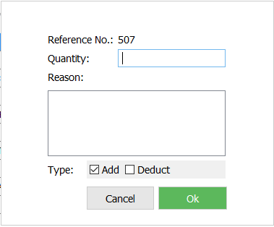**Quantity**

Quantity

1 1*1*

Type

Reason

3 1*1*

2 1*1*

**1.1) Quantity**

Input quantity to be added or deducted.

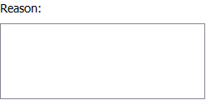**1.2) Reason**

Input the reason why to adjust item.

**1.3) Type**

Select type of the adjust.   
  
You can see the adjustment made in the item by clicking the report tab

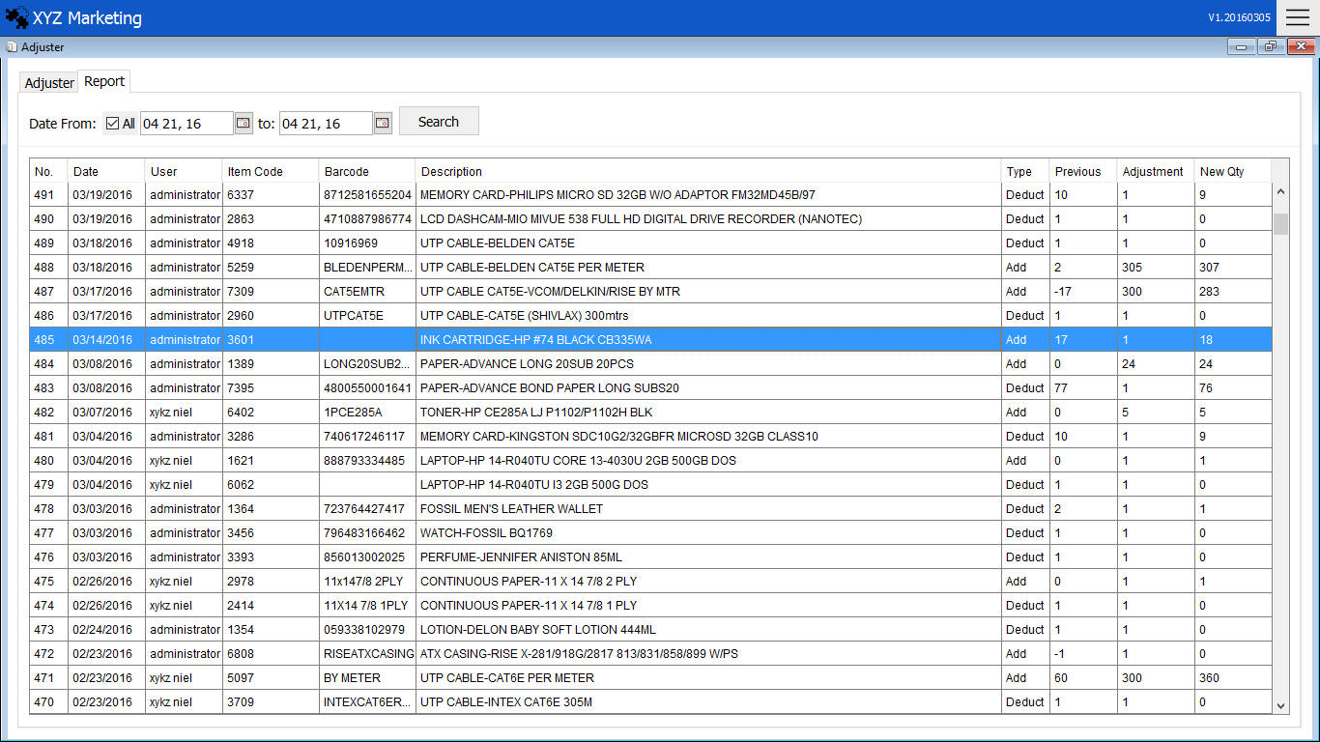

Report